**Subcommittee Chair: Lester Millet III, Port of South Louisiana**

**Executive Secretary: Mr. Nick Parham**

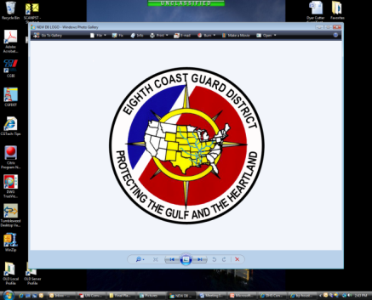

**Gulf of Mexico Area Maritime Security Committee:**

**Maritime Domain Awareness**

**Subcommittee Meeting**

February 26, 2019

1000 – 1200

at

**Terrebonne Parish OHSEP Emergency Operations Center**

**101 Government Street**

**Gray, LA 70359**

**Gulf of Mexico Area Maritime Security (AMSC) Subcommittee Meeting**

**AGENDA**

1000-1005 **Administration**

* LCDR Mickey Dougherty, D8 OCS OCMI

1005-1015 **Welcome and Remarks from Subcommittee Chair**

* Mr. Lester Millet III, Chair, Maritime Domain Awareness Subcommittee

1015-1050  **DHS Rapid Survey Tool (RST) Overview**

* Mr. Jim Orgill, ID Technology Partners

1050-1100 **Break**

1100-1130 **DHS CBP Aviation Operations Overview**

* Mr. Jason Woody, U.S. Customs and Border Protection

1130-1145 **National Strategic Research Initiative Port Visit Update**

* Ms. April Danos, Greater Lafourche Port Commission

1145-1200 **Agency Reports and Upcoming Sub-Committee Meetings, Discussion**

* Facilitated by LCDR Dougherty

1200 **Wrap Up / Adjourn**